**Version Control**

|  |  |  |  |
| --- | --- | --- | --- |
|  | Name | Date | Email |
| Owner | Vaheedbasha Shaik | 21/Apr/2024 | vaheedbasha.shaik@res.christuniversity.in |
| Technical Reviewer | Natarajan K | 28/Apr/2024 | natarajan.k@christuniversity.in |

**By:**

**Vaheedbasha Shaik & Dr.Natarajan K**

**Purpose:** To reproduce the proposed methodology this document has been prepared.

**Observations:**

1. These steps are prepared by decoding the algorithm and for manual execution. You might see more series of steps in the screenshots. So, please compare only the series of steps of algorithm and Manual executions.
2. After every step execution the server screenshot provided, and the same text copied also copied in the text format.

**Code:** The github has these operations are automated, no manual execution required. These steps are for reader’s understanding.

**Software:** Please use Oracle Cloud Infrastructure with Oracle database.

**Infrastructure:**

| Server Type | Resource Configurations | | |
| --- | --- | --- | --- |
| CPU’s | RAM | SWAP |
| Active/Primary | 8 | 31 | 7 |
| Passive/Standby | 2 | 6 | 3 |

**Keywords:**

1. Active or Primary database refers to the same word.
2. Passive or standby refers to the same word.

**Step 1: Installation of Configuration of Active server on Cloud**

Primary CPU:

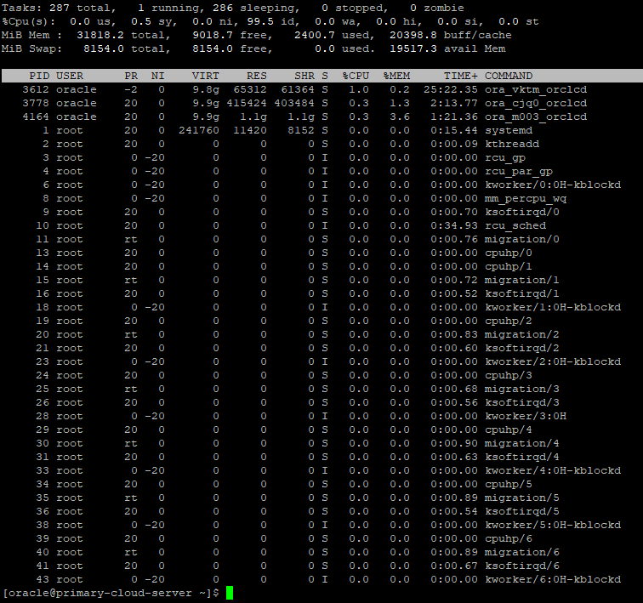

[oracle@primary-cloud-server ~]$ lscpu

Architecture: x86_64

CPU op-mode(s): 32-bit, 64-bit

Byte Order: Little Endian

CPU(s): 8

On-line CPU(s) list: 0-7

Thread(s) per core: 2

Core(s) per socket: 4

Socket(s): 1

NUMA node(s): 1

Vendor ID: AuthenticAMD

CPU family: 23

Model: 1

Model name: AMD EPYC 7551 32-Core Processor

Stepping: 2

CPU MHz: 1996.249

BogoMIPS: 3992.49

Hypervisor vendor: KVM

Virtualization type: full

L1d cache: 64K

L1i cache: 64K

L2 cache: 512K

L3 cache: 16384K

NUMA node0 CPU(s): 0-7

Flags: fpu vme de pse tsc msr pae mce cx8 apic sep mtrr pge mca cmov pat pse36 clflush mmx fxsr sse sse2 ht syscall nx mmxext fxsr_opt pdpe1gb rdtscp lm rep_good nopl cpuid extd_apicid tsc_known_freq pni pclmulqdq ssse3 fma cx16 sse4_1 sse4_2 x2apic movbe popcnt tsc_deadline_timer aes xsave avx f16c rdrand hypervisor lahf_lm cmp_legacy cr8_legacy abm sse4a misalignsse 3dnowprefetch osvw topoext perfctr_core ssbd ibpb vmmcall fsgsbase tsc_adjust bmi1 avx2 smep bmi2 rdseed adx smap clflushopt sha_ni xsaveopt xsavec xgetbv1 xsaves nt_good clzero xsaveerptr virt_ssbd arat arch_capabilities

[oracle@primary-cloud-server ~]$ nproc

8

[oracle@primary-cloud-server ~]$ free -g

total used free shared buff/cache available

Mem: 31 2 8 9 19 19

Swap: 7 0 7

[oracle@primary-cloud-server ~]$

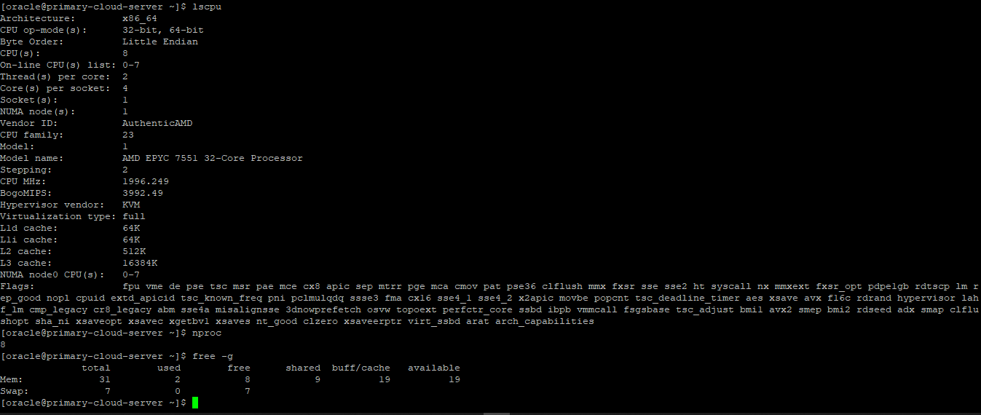

**Step 2: Installation of Configuration of Passive server on Cloud**

Passive CPU:

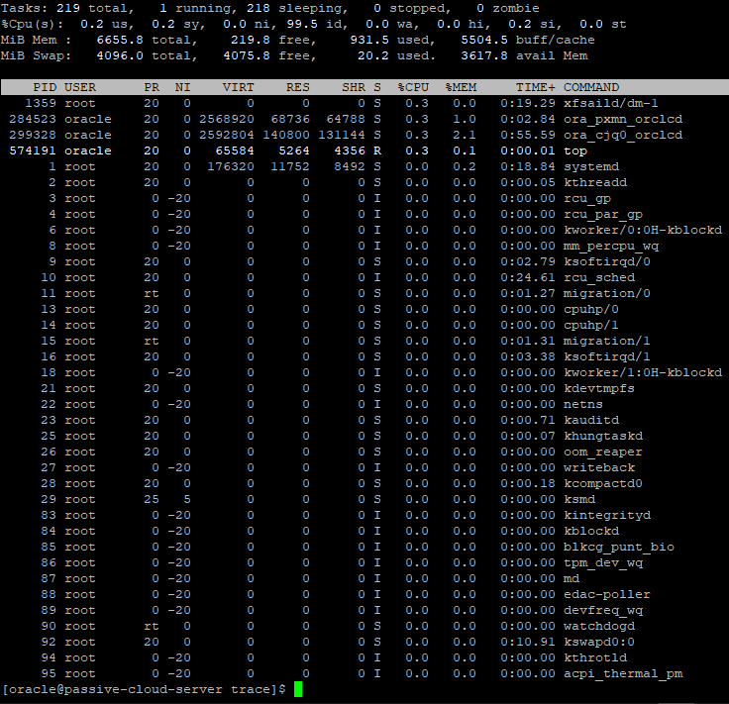

[oracle@passive-cloud-server trace]$ lscpu

Architecture: x86_64

CPU op-mode(s): 32-bit, 64-bit

Byte Order: Little Endian

CPU(s): 2

On-line CPU(s) list: 0,1

Thread(s) per core: 2

Core(s) per socket: 1

Socket(s): 1

NUMA node(s): 1

Vendor ID: GenuineIntel

CPU family: 6

Model: 63

Model name: Intel(R) Xeon(R) CPU E5-2699 v3 @ 2.30GHz

Stepping: 2

CPU MHz: 2294.876

BogoMIPS: 4589.75

Virtualization: VT-x

Hypervisor vendor: KVM

Virtualization type: full

L1d cache: 32K

L1i cache: 32K

L2 cache: 4096K

L3 cache: 16384K

NUMA node0 CPU(s): 0,1

Flags: fpu vme de pse tsc msr pae mce cx8 apic sep mtrr pge mca cmov pat pse36 clflush mmx fxsr sse sse2 ss ht syscall nx pdpe1gb rdtscp lm constant_tsc arch_perfmon rep_good nopl xtopology cpuid tsc_known_freq pni pclmulqdq vmx ssse3 fma cx16 pdcm pcid sse4_1 sse4_2 x2apic movbe popcnt tsc_deadline_timer aes xsave avx f16c rdrand hypervisor lahf_lm abm cpuid_fault invpcid_single pti ssbd ibrs ibpb stibp tpr_shadow vnmi flexpriority ept vpid ept_ad fsgsbase tsc_adjust bmi1 avx2 smep bmi2 erms invpcid xsaveopt arat umip md_clear arch_capabilities

[oracle@passive-cloud-server trace]$ nproc

2

[oracle@passive-cloud-server trace]$ free -g

total used free shared buff/cache available

Mem: 6 0 0 1 5 3

Swap: 3 0 3

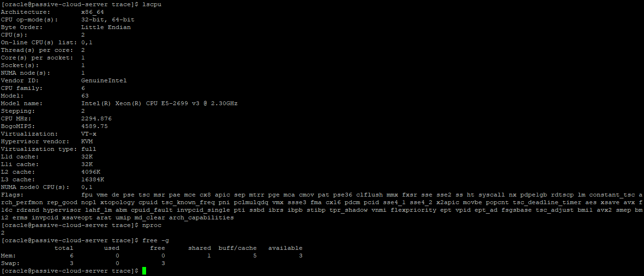

**Step 3: Active or Primary database configuration on Cloud**

Primary database:

HOST_NAME INSTANCE_N STATUS LOGINS DATABASE_S ACTIVE_STA NAME DATABASE_ROLE VERSION OPEN_MODE STARTUP_TIME

-------------------- ---------- ------------ ---------- ---------- ---------- ---------- ---------------- ------------ -------------------- --------------------

primary-cloud-server ORCLCDB OPEN ALLOWED ACTIVE NORMAL ORCLCDB PRIMARY 21.0.0.0.0 READ WRITE 06-JUL-22 10:38:44



**Step 4: Active or Primary database configuration on Cloud**

Passive Database:

HOST_NAME INSTANCE_N STATUS LOGINS DATABASE_S ACTIVE_STA NAME DATABASE_ROLE VERSION OPEN_MODE STARTUP_TIME

------------------------ ---------- ------------ ---------- ---------- ---------- ---------- ---------------- ------------ ------------- --------------------

passive-cloud-server ORCLCDB OPEN ALLOWED ACTIVE NORMAL ORCLCDB PRIMARY 21.0.0.0.0 READ WRITE 07-JUL-22 08:33:12



**Step 5: Full restoration of passive server on Cloud**

RMAN> startup nomount;

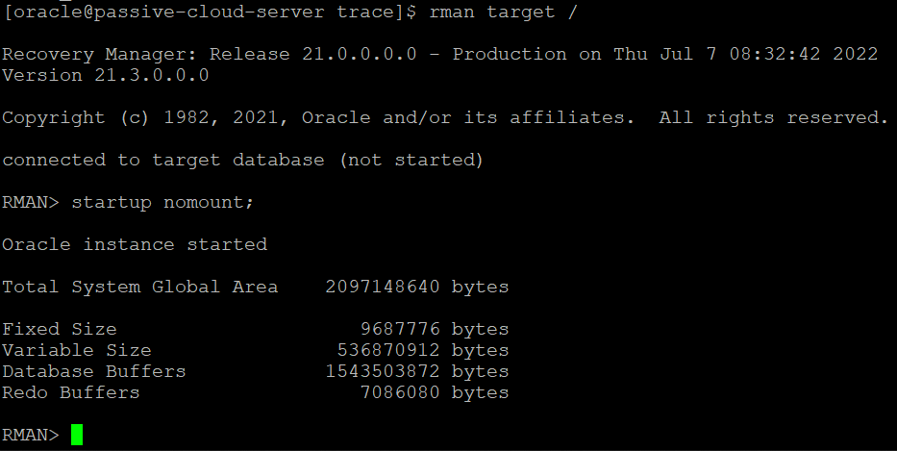

RMAN> restore controlfile from service 'primary-cloud-server';

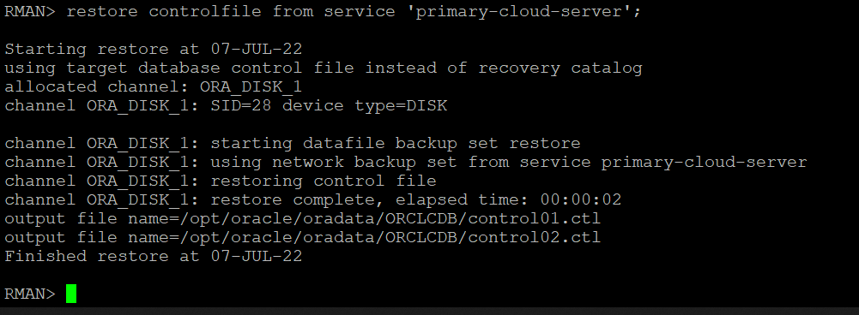

RMAN> restore database from service 'primary-cloud-server';

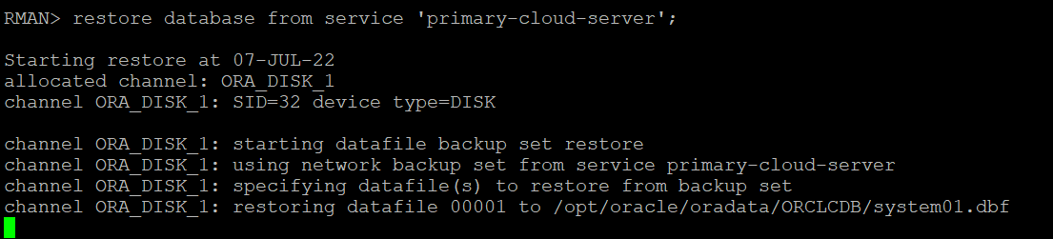

**Step 6: Compare Active and Passive databases data files after Full restoration of passive database on Cloud.**

Primary: SQL> select HXFIL File_num,fhscn from x$kcvfh;

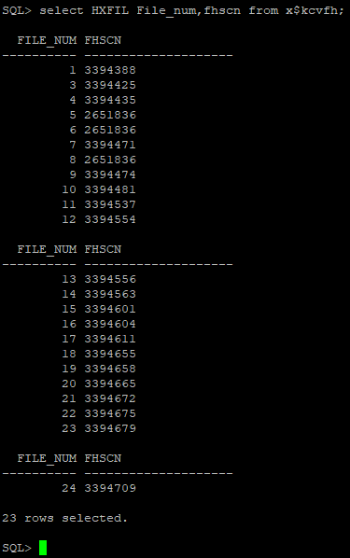

Standby Level 0 restore: SQL> select HXFIL File_num,fhscn from x$kcvfh;

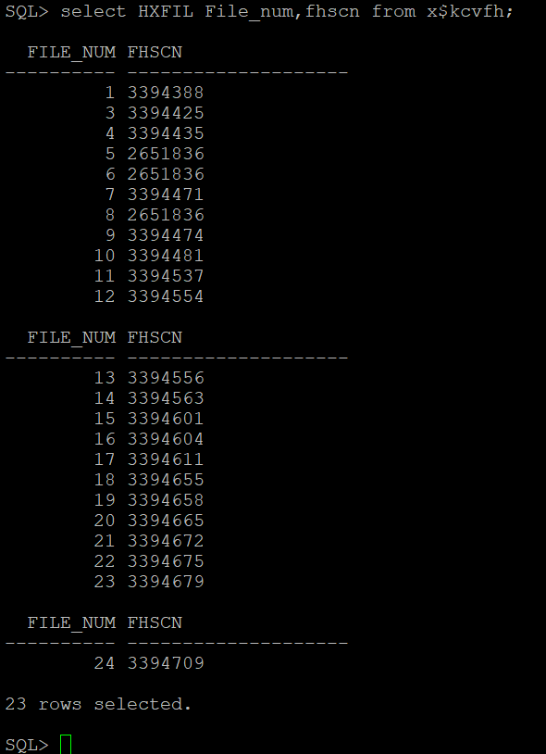

**Step 7: Perform some DDL & DML commands on active database to simulate the transactions on active database.**

Primary :performed some changes for level 1 recovery

SQL> alter session set container =ORCLPDB1;

Session altered.

SQL> create table test1.t as select * from dba_users;

Table created.

SQL> create table test1.t2 as select * from dba_tables;

Table created.

SQL> delete from test1.t2;

2350 rows deleted.

SQL> commit;

Commit complete.

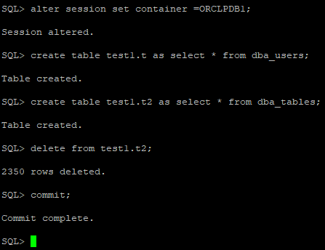

**Step 8: After new transactions, check the modified File Header System Change Number(FHSCN)on active database.**

Primary: fhscn numbers at level -1 recovery in primary

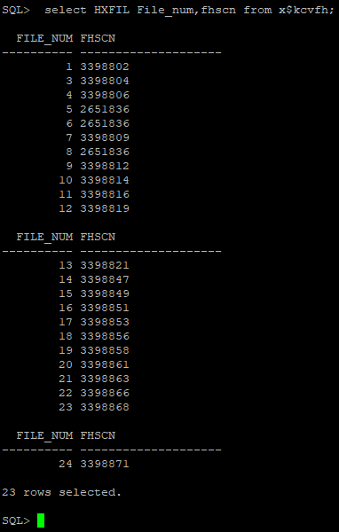

**Step 9: Initiate the 1st Iteration of the Recovery on Passive database.**

Standby: level-1 recover after sql updates in primary:

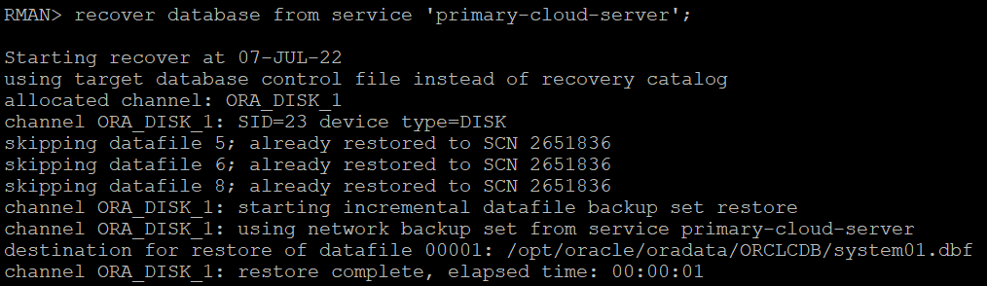

**Step 10: Check the synchronized FHSCN values on Passive database with Step 8 results of active database.**

standby: fhscn numbers after level -1 recovery in standby

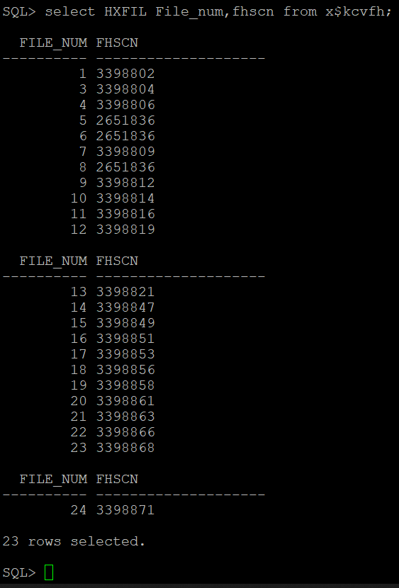

**Step 11: Continue with the step 8,9, and 10 till the cutover data or Last iteration of restoration on passive database.**

**Step 12: Check the Delta changes on active databases before Nth Iteration of recovery.**

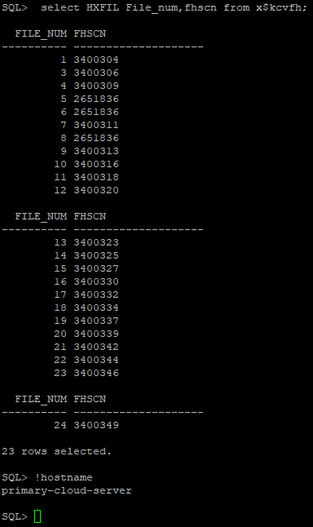

**Step 13: Check the applied Delta changes on passive databases after Nth Iteration of recovery.**

standby: fhscn numbers after level Nth recovery in standby

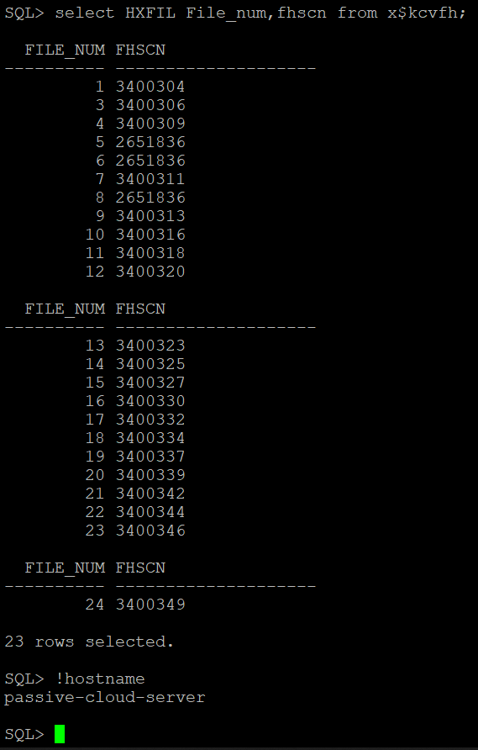

**Step 14: Expected error after Nth Iteration of Passive database recovery.**

Standby:The Expected Error in standby recovery.

unable to find archived log

archived log thread=1 sequence=112

RMAN-00571: ===========================================================

RMAN-00569: =============== ERROR MESSAGE STACK FOLLOWS ===============

RMAN-00571: ===========================================================

RMAN-03002: failure of recover command at 07/07/2022 09:22:54

RMAN-06054: media recovery requesting unknown archived log for thread 1 with sequence 112 and starting SCN of 3394339

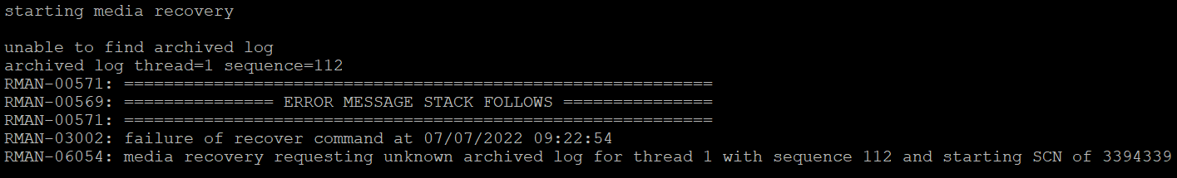

**Step 15: To resolve the error on step 14, execute these commands on primary.**

Primary: Perform archivelog switch in primary

SQL> !hostname

primary-cloud-server

SQL> alter system checkpoint;

System altered.

SQL> alter system switch logfile;

System altered.

SQL> /

System altered.

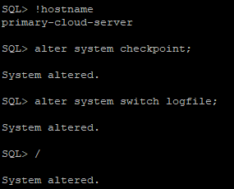

**Step 16: To resolve the error on step 14, Perform archivelog transfer to standby/Passive database.**

Primary: Perform archivelog transfer to standby.

[oracle@primary-cloud-server dbs]$ scp arch1_11* 10.0.0.213:/opt/oracle/reco/.

arch1_110_1107884035.dbf 100% 160MB 70.6MB/s 00:02

arch1_11_1107884035.dbf 100% 5632 11.6KB/s 00:00

arch1_111_1107884035.dbf 100% 159MB 92.5MB/s 00:01

arch1_112_1107884035.dbf 100% 42MB 65.7MB/s 00:00

arch1_113_1107884035.dbf 100% 5120 3.7MB/s 00:00

arch1_114_1107884035.dbf 100% 12KB 8.7MB/s 00:00

arch1_115_1107884035.dbf 100% 6144 4.8MB/s 00:00

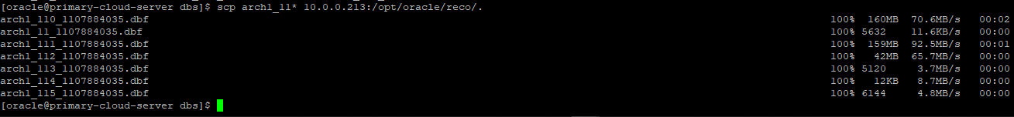

**Step 17: To resolve the error on step 14, catalog the shipped archive logs on passive database.**

Standby: catalog the archive logs in standby.

[oracle@passive-cloud-server reco]$ pwd

/opt/oracle/reco

[oracle@passive-cloud-server reco]$ ls -ltrh

total 362M

-rw-r----- 1 oracle oinstall 161M Jul 7 09:35 arch1_110_1107884035.dbf

-rw-r----- 1 oracle oinstall 160M Jul 7 09:35 arch1_111_1107884035.dbf

-rw-r----- 1 oracle oinstall 42M Jul 7 09:35 arch1_112_1107884035.dbf

-rw-r----- 1 oracle oinstall 5.0K Jul 7 09:35 arch1_113_1107884035.dbf

-rw-r----- 1 oracle oinstall 12K Jul 7 09:35 arch1_114_1107884035.dbf

-rw-r----- 1 oracle oinstall 6.0K Jul 7 09:35 arch1_115_1107884035.dbf

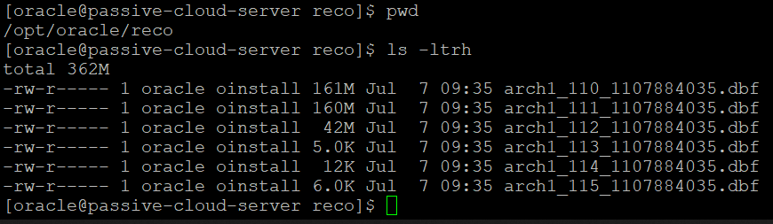

[oracle@passive-cloud-server reco]$ rman target /

Recovery Manager: Release 21.0.0.0.0 - Production on Thu Jul 7 09:36:50 2022

Version 21.3.0.0.0

Copyright (c) 1982, 2021, Oracle and/or its affiliates. All rights reserved.

connected to target database: ORCLCDB (DBID=2878945410, not open)

RMAN> catalog start with '/opt/oracle/reco/';

using target database control file instead of recovery catalog

searching for all files that match the pattern /opt/oracle/reco/

List of Files Unknown to the Database

=====================================

File Name: /opt/oracle/reco/arch1_110_1107884035.dbf

File Name: /opt/oracle/reco/arch1_111_1107884035.dbf

File Name: /opt/oracle/reco/arch1_112_1107884035.dbf

File Name: /opt/oracle/reco/arch1_113_1107884035.dbf

File Name: /opt/oracle/reco/arch1_114_1107884035.dbf

File Name: /opt/oracle/reco/arch1_115_1107884035.dbf

Do you really want to catalog the above files (enter YES or NO)? yes

cataloging files...

cataloging done

List of Cataloged Files

=======================

File Name: /opt/oracle/reco/arch1_110_1107884035.dbf

File Name: /opt/oracle/reco/arch1_111_1107884035.dbf

File Name: /opt/oracle/reco/arch1_112_1107884035.dbf

File Name: /opt/oracle/reco/arch1_113_1107884035.dbf

File Name: /opt/oracle/reco/arch1_114_1107884035.dbf

File Name: /opt/oracle/reco/arch1_115_1107884035.dbf

RMAN>

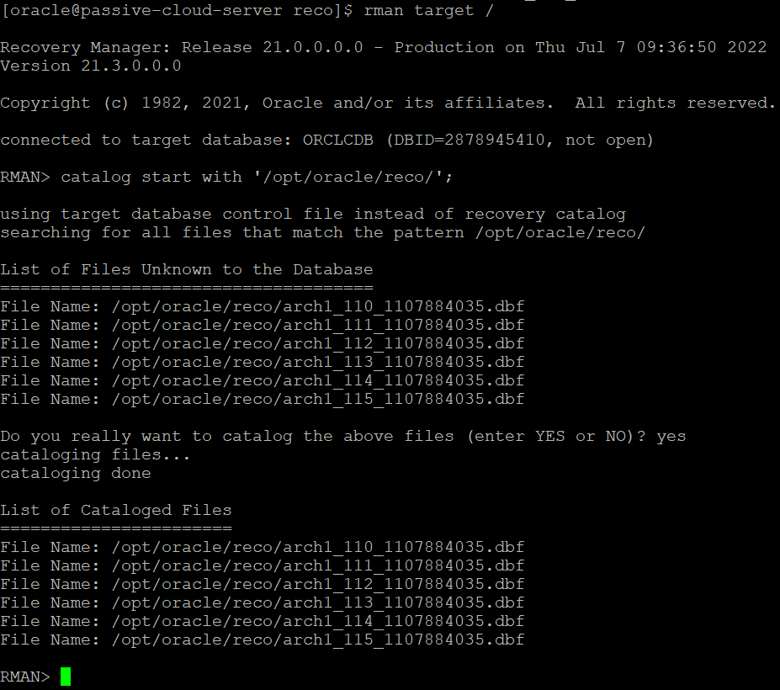

**Step 18: To resolve the error on step 14, recover passive database till you receive the message** RMAN-06054**.**

Standby: Recover database:

RMAN> recover database;

Starting recover at 07-JUL-22

allocated channel: ORA_DISK_1

channel ORA_DISK_1: SID=32 device type=DISK

starting media recovery

archived log for thread 1 with sequence 112 is already on disk as file /opt/oracle/reco/arch1_112_1107884035.dbf

archived log for thread 1 with sequence 113 is already on disk as file /opt/oracle/reco/arch1_113_1107884035.dbf

archived log for thread 1 with sequence 114 is already on disk as file /opt/oracle/reco/arch1_114_1107884035.dbf

archived log for thread 1 with sequence 115 is already on disk as file /opt/oracle/reco/arch1_115_1107884035.dbf

archived log file name=/opt/oracle/reco/arch1_112_1107884035.dbf thread=1 sequence=112

archived log file name=/opt/oracle/reco/arch1_113_1107884035.dbf thread=1 sequence=113

archived log file name=/opt/oracle/reco/arch1_114_1107884035.dbf thread=1 sequence=114

archived log file name=/opt/oracle/reco/arch1_115_1107884035.dbf thread=1 sequence=115

unable to find archived log

archived log thread=1 sequence=116

RMAN-00571: ===========================================================

RMAN-00569: =============== ERROR MESSAGE STACK FOLLOWS ===============

RMAN-00571: ===========================================================

RMAN-03002: failure of recover command at 07/07/2022 09:38:54

RMAN-06054: media recovery requesting unknown archived log for thread 1 with sequence 116 and starting SCN of 3400741

RMAN>

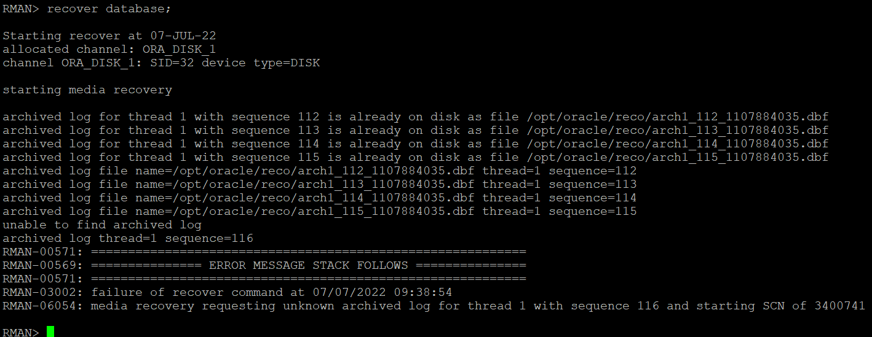

**Step 19: Open the passive database in open state.**

Standby: Open database with resetlogs.

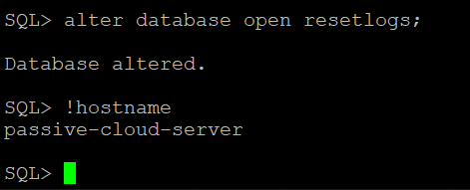

**Step 20: The database is migrated to target side and available for connections.**



**Conclusion:**

The results of the experiments in this paper indicate that the proposed framework appears efficient in a practical situation based on the outcomes.